KPP-CBPS colloquium on Girls’ Education & Empowerment: Sharing of Research Findings on Selected Strategies- 7th January, 2015
The Centre for Budget and Policy Studies (CBPS) in partnership with CARE India supported by DFID India and IPE Global under its Knowledge Partnership Programme (KPP) held a Colloquium on January 7th 2015, in Delhi. The colloquium focused on research findings of two studies: Residential Schooling for Girls Education and Empowerment: The Missing Links (research conducted by CBPS supported under the Knowledge Partnership Programme) and Special Training Programme - Realities, Issues and Challenges: A Study of Select Districts of Bihar, Gujarat, Odisha and Uttar Pradesh (Conducted by CARE India).
The panel on the first study raised questions regarding scaling up of success-stories, learning achievements of JNV students, aspects of social and emotional environment, ability to cope with curriculum, gendered dimension indiscipline and artificial drop-outs. Observations regarding non-functional and non-existing toilets in many KGBVs were also made. The second presentation, by Dr. Suman Sachdeva, CARE India, outlined the review of the curriculum and current status of implementation of Special Training Programme (STP) as mandated by Right to Education in states, where CARE-India’s Girls' Education Programme unit has been active.
The colloquium was attended by approximately 50 key stakeholders including academics, government and ministry officials, researchers and scholars working on issues of education and empowerment of women.
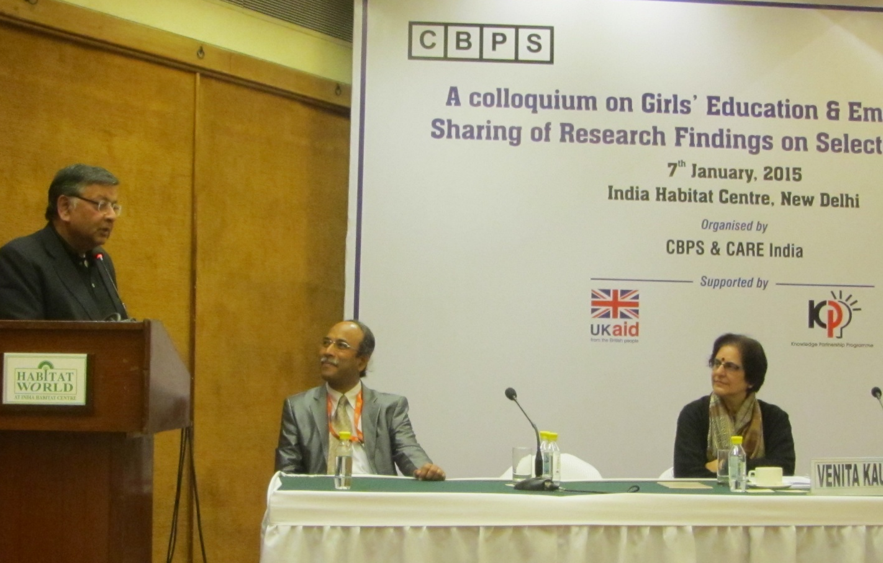
Mr Sunil Mitra, Team Lead, KPP, IPE Global gives the closing remarks as Musa Muhammed, CEO CARE-India and Dr. Venita Kaul,Professor, Ambedkar University, New Delhi.

